Volume of cylinders and solid sectors worksheet

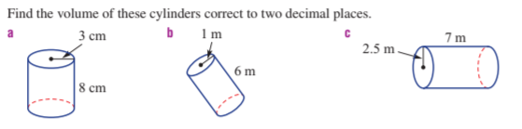
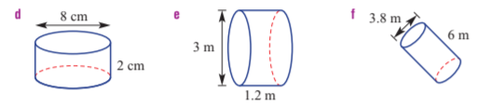
 | A water tank is in the shape of a cylinder. It has a diameter of 3 metres and a height of 2 metres. What is its volume?
 | 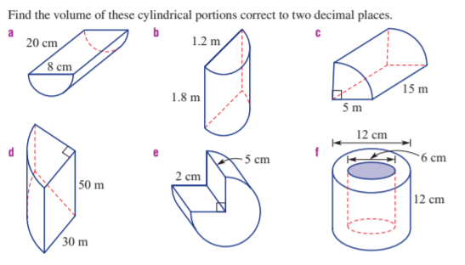
4. | Which has a bigger volume and what is the difference in volume to two decimal places? A cube with side length 1 m or a cylinder with radius 1 m and height 0.5 m.

Volume of cylinders and solid sectors worksheet



 | A water tank is in the shape of a cylinder. It has a diameter of 3 metres and a height of 2 metres. What is its volume?
 | 
4. | Which has a bigger volume and what is the difference in volume to two decimal places? A cube with side length 1 m or a cylinder with radius 1 m and height 0.5 m.

